37.77: a) In the center of momentum frame, the two protons approach each other with equal velocities (since the protons have the same mass). After the collision, the two protons are at rest─but now there are kaons as well. In this situation the kinetic energy of the protons must equal the total rest energy of the two kaons 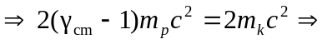
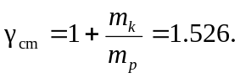 The velocity of a proton in the center of momentum frame is then 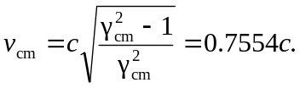
To get the velocity of this proton in the lab frame, we must use the Lorentz velocity transformations. This is the same as “hopping” into the proton that will be our target and asking what the velocity of the projectile proton is. Taking the lab frame to be the unprimed frame moving to the left, 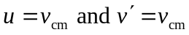(the velocity of the projectile proton in the center of momentum frame).
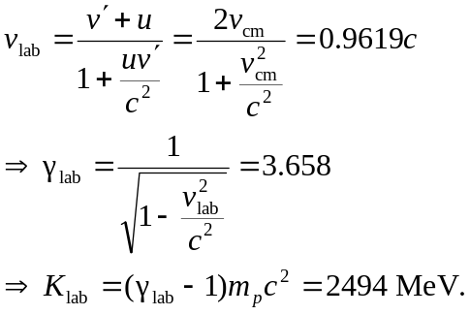
b) 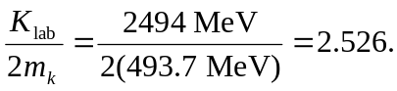
c) The center of momentum case considered in part (a) is the same as this situation. Thus, the kinetic energy required is just twice the rest mass energy of the kaons. 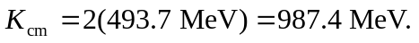This offers a substantial advantage over the fixed target experiment in part (b). It takes less energy to create two kaons in the proton center of momentum frame.

